|  |  |  |  |
| --- | --- | --- | --- |
| **Project Name: WMS Implementation for AlMailem** | | | |
| Project Manager | Rajasekar | Document Version | 1.1 |
| Technical /Functional Consultants | Senthil, Mugilan, Karthik, Bharathi | Document Date | 18.05.2023 |
| Delivery Manager | Murugavel | Prepared on | 18.05.2023 |
| Prepared by | Rajasekar | Reviewed by | Domnic Regies |

**Distribution Information**

|  |  |  |  |
| --- | --- | --- | --- |
| **From: Tekclover Private Limited** | | | |
| **To : AlMailem** | | Acceptance/Sign off | Sign-off date |
| Project Manager - Operations  (AlMailem) | Mr. Prathap Rana |  |  |
| Project Manager - IT  (AlMailem) | Mr. Wajahath |  |  |
| Project Manager  (Tekclover) | Mr.Rajasekar |  |  |

**Version Information**

|  |  |  |  |
| --- | --- | --- | --- |
| Ver No | Ver Date | Revised by | Description/File Name |
| 1.0 | 18.05.2023 | Rajasekar | AlMailem WMS Implementation – Business Blue Print – V 1.0 |
| 1.1 | 22.05.2023 | Rajasekar | AlMailem WMS Implementation – Business Blue Print – V 1.1 |

Contents

**1.** **PURPOSE OF DOCUMENT** 5

**2.** **INTENDED AUDIENCE** 5

**3.** **Project Scope** 5

**4.** **Business Process (To-Be) – Setup and Masters** 6

**4.1 Setup - Organization** 6

**4.1.1 Company Code** 6

**4.1.2 Branch Code** 6

**4.1.3 Warehouse No** 7

**4.1.4 Floor** 7

**4.1.4 Storage Section or Zones** 7

**4.2** **Setup – Product** 8

**4.2.1** **Item type** 8

**4.2.2** **Item group** 8

**4.2.3** **FEFO Management** 9

**4.2.4** **Variant Management** 9

**4.3** **Setup – Storage** 10

**4.3.1** **Storage Class** 10

**4.3.2** **Storage Type** 10

**4.3.3** **Storage Bin type** 10

**4.3.4** **Strategies** 10

**4.4** **Master – Product** 11

**4.5** **Master – Storage Bin** 11

**4.6** **Master – Handling Equipment** 12

**4.7** **Master – BOM** 12

**4.8** **Master – Packing** 12

**5.** **Business Process (To-Be) – Transactions** 13

**5.1** **Inbound - Amghara** 14

**5.1.1** **Process Flow** 14

**5.1.2** **Process Steps:** 15

**5.2** **Make and Change – Amghara** 17

17

**5.2.1** **Process Flow** 17

**5.2.2** **Process Steps** 18

**5.3** **Outbound - Amghara** 19

**5.3.1** **Process Flow** 19

**5.3.2** **Process Steps** 20

**5.4** **Stock Count (Perpetual and Periodic)** 23

**5.4.1** **Process Flow** 23

**5.4.2** **Process Steps** 24

**5.5** **Inbound – Auto Lab** 25

**5.5.1** **Process Flow** 25

**5.5.2** **Process Steps:** 26

**5.6** **Make and Change – Auto Lab** 28

**5.6.1** **Process Flow** 28

**5.6.2** **Process Steps** 29

**5.7** **Outbound – Auto Lab** 30

**5.7.1** **Process Flow** 30

**5.7.2** **Process Steps** 31

**5.8** **Stock Count** 34

**5.8.1** **Process Flow** 34

**5.8.2** **Process Steps** 35

**6.** **Stock Transfers between Warehouses** 36

**6.1** **Process Flow** 36

**6.2** **Process Steps** 37

**7.** **Delivery Module** 38

**7.1** **Process Flow** 38

**7.2** **Process Steps** 39

**8.** **Reports and Dashboard** 40

**8.1** **Reports** 40

**8.2** **Dashboard** 40

**9.** **Forms** 41

**10.** **Open Points** 41

**11.** **Points Discussed** 41

# **PURPOSE OF DOCUMENT**

The primary purpose of this document is to capture the functional requirements of AlMailem, Kuwait for the WMS implementation to accommodate their business scenarios for their Warehouses (Amghara and Auto Lab). This document is prepared based on the business analysis conducted by Tekclover Pvt Ltd. It captures the business processes of WMS and Delivery Module and the detailed scope of the project deliverable.

The Blueprint and its associated appendices present a summarized perspective of all functional business

processes that will be implemented. Blueprint document will serve - from this point forward the dual role of both official project scope as well as system acceptance criteria.

The body of this document describes the organizational structure, Masters, and functional process flows to be implemented at AlMailem Warehouses. Generally, requirements can be met based on the standard business and system benchmarks accepted globally. However, certain key requirements are explicitly identified and summarized to highlight their importance to AlMailem, to document the approach proposed to meet the requirement.

# **INTENDED AUDIENCE**

This document is intended for review by various user groups within AlMailem with vested interests in this project. These groups should check the validity of business assumptions, the accuracy of the business functions, outputs, and the flow of processing logic described in the document. When

accepted, it will form the basis for the detailed design and development of the system.

This document is also meant for Tekclover Pvt Ltd., in the design, development, and testing phases of the system.

# **Project Scope**

Scope of this project is to implement WMS which covers below

* To Implement Warehouse Management and Delivery Management through Classic WMS for AlMailem Group.
* Number of Warehouses covered in the Scope – 2 Warehouses (Auto Lab & Amghara), 2 Sub Inventories (ASP(USA) & JSP(Japan))
* Delivery Management System has to be implemented for Auto Lab
* Integration of Classic WMS with AMS system for the agreed integration touch points
* Mobile Application for WMS that support Android based Hand Held Terminals
* Mobile Application for Delivery that Support Android Mobile devices
* Warehouse Modules are as below
* Setup
* Masters
* Inbound & Returns
* Make and Change (Transfers)
* Outbound & Returns
* Stock Count
* Delivery
* Reports and Dashboard

# **Business Process (To-Be) – Setup and Masters**

WMS implementation for AlMailem warehouses will cover below business processes

## **4.1 Setup - Organization**

Organizational units for AlMailem Warehouses include company code, Warehouse No, Floor and Storage section or Zone.

### **4.1.1 Company Code**

A company code is the smallest organizational unit for which a complete, self-contained set of accounts can be drawn up.

For AlMailem, below company codes will be defined in Classic WMS

|  |  |  |
| --- | --- | --- |
| S.NO | Company code | Company name |
| 1 | 21 | AlMailem – Japanese Spare Parts |
| 2 | 23 | AlMailem – American Spare Parts |

**4.1.2 Branch Code**

For AlMailem, below branch codes will be defined in Classic WMS

|  |  |  |  |
| --- | --- | --- | --- |
| S.NO | Company code | Branch Code | Company name |
| 1 | 21 | 212 | Amghara – American Spare Parts |
| 2 | 23 | 115 | Amghara – Japanese Spare Parts |
| 3 | 21 | 222 | Auto Lab – American Spare Parts |
| 4 | 23 | 125 | Auto Lab – Japanese Spare Parts |

### **4.1.3 Warehouse No**

Number of Warehouses considered in this project for the phase-1 will be 2.

Warehouse Number for AlMailem Warehouses will be defined in Classic WMS as below

|  |  |  |  |  |
| --- | --- | --- | --- | --- |
| S.NO | Company code | Branch Code | Warehouse No | Description |
| 1 | 21 | 212 | 100 | Amghara Warehouse |
| 2 | 23 | 115 | 100 | Amghara Warehouse |
| 3 | 21 | 222 | 200 | Auto Lab Warehouse |
| 4 | 23 | 125 | 200 | Auto Lab Warehouse |

### **4.1.4 Floor**

Number of Floors considered in this project for the phase-1 will be 7

Floor Numbers for AlMailem Warehouses will be defined in Classic WMS as below

|  |  |  |  |
| --- | --- | --- | --- |
| S.NO | Warehouse No | Floor No | Company name |
| 1 | 100 | 1 | Ground floor |
| 2 | 100 | 2 | Mezzanine Floor |
| 3 | 100 | 3 | First floor |
| 4 | 200 | 1 | Ground floor |
| 5 | 200 | 2 | Basement 1 floor |
| 6 | 200 | 3 | Basement 2 floor |
| 7 | 200 | 4 | Basement 3 floor |

### **4.1.4 Storage Section or Zones**

Number of Zones considered in this project will be four

Zone Numbers for AlMailem Warehouses will be defined as below in Classic WMS

|  |  |  |
| --- | --- | --- |
| Warehouse No | Floor No | Zone No |
| 100 | 1 | A1 |
| 100 | 1 | B1 |
| 100 | 1 | C1 |
| 100 | 1 | D1 |
| 100 | 2 | A2 |
| 100 | 2 | B2 |
| 100 | 2 | C2 |
| 100 | 2 | D2 |
| 100 | 3 | A3 |
| 100 | 3 | B3 |
| 100 | 3 | C3 |
| 100 | 3 | D3 |
| 200 | 2 | A1 |
| 200 | 2 | B1 |
| 200 | 2 | C1 |
| 200 | 2 | D1 |
| 200 | 3 | A2 |
| 200 | 3 | B2 |
| 200 | 3 | C2 |
| 200 | 3 | D2 |
| 200 | 4 | A3 |
| 200 | 4 | B3 |
| 200 | 4 | C3 |
| 200 | 4 | D3 |

## **Setup – Product**

Product Setup for AlMailem Warehouses include item type, item group, Batch/Serial and Variant management setups

### **Item type**

Item type for AlMailem Warehouses will be maintained as 1- stockable in Classic WMS

### **Item group**

Item group for AlMailem will be maintained as below in Classic WMS

|  |  |  |  |
| --- | --- | --- | --- |
| S. No | Company code | Item group | Item group description |
| 1 | 21 | 1 | A/C parts |
| 2 | 21 | 2 | Bearing |
| 3 | 21 | 3 | Brake system |
| 4 | 21 | 4 | Clutch / transmission / differential parts |
| 5 | 21 | 5 | Collision parts |
| 6 | 21 | 6 | Electrical parts |
| 7 | 21 | 7 | Engine parts |
| 8 | 21 | 8 | Filter |
| 9 | 21 | 9 | Lubricant/battery |
| 10 | 21 | 10 | Pump |
| 11 | 21 | 11 | Suspension & steering parts |
| 12 | 21 | 12 | Universal parts |
| 13 | 21 | 13 | Not defined |
| 14 | 21 | 14 | Computers |
| 15 | 21 | 15 | Furniture & fixture |
| 16 | 21 | 16 | Office eqpmts |
| 17 | 21 | 17 | Racking system |
| 18 | 21 | 18 | Vehicles |
| 19 | 23 | 1 | A/c parts |
| 20 | 23 | 2 | Bearing |
| 21 | 23 | 3 | Brake system |
| 22 | 23 | 4 | Clutch / transmission / differential parts |
| 23 | 23 | 5 | Collision parts |
| 24 | 23 | 6 | Default |
| 25 | 23 | 7 | Electrical parts |
| 26 | 23 | 8 | Engine parts |
| 27 | 23 | 9 | Filter |
| 28 | 23 | 10 | Lubricant/battery |
| 29 | 23 | 11 | Pump |
| 30 | 23 | 12 | Suspension & steering parts |
| 31 | 23 | 13 | Universal parts |
| 32 | 23 | 14 | Not defined |
| 33 | 23 | 15 | Computers |
| 34 | 23 | 16 | Furniture & fixture |
| 35 | 23 | 17 | Office eqpmts |
| 36 | 23 | 18 | Plant, machinery & t |
| 37 | 23 | 19 | Racking system |
| 38 | 23 | 20 | Vehicles |
| 39 | 23 | 21 | Non stockable parts |

### **FEFO Management**

FEFO management is required for few item groups (parts under Warranty) – List of items need to be shared by business

### **Variant Management**

Variant Management for AlMailem Warehouses is not applicable

## **Setup – Storage**

Storage Setup for AlMailem Warehouses include storage class, storage type, storage bin type and strategies setups.

### **Storage Class**

Storage class for AlMailem Warehouses will be maintained as 1- General storage class in Classic WMS by default

### **Storage Type**

Storage Type for AlMailem Warehouses will be maintained as below

|  |  |  |  |
| --- | --- | --- | --- |
| S.NO | Warehouse | Storage ID | Storage Name |
| 1 | 100 | 1 | Standard |
| 2 | 100 | 2 | Open |
| 3 | 200 | 1 | Standard |

### **Storage Bin type**

Storage Bin Type for AlMailem Warehouses will be maintained as 1- General storage Bin Type in Classic WMS by default

### **Strategies**

Below strategies will be adopted for inbound and Outbound

|  |  |  |  |  |  |  |
| --- | --- | --- | --- | --- | --- | --- |
| **S. No** | **Module** | **Warehouse** | **Process** | **Strategies** | | |
| **Priority-1** | **Priority-2** | **Priority-3** |
| 1 | Inbound | 100 | Putaway | Add to Existing stock | New Bin Location | Virtual loc |
| 2 | Outbound | 100 | Picking | 1.FIFO (as per received date & Time)  2. FIFO (based on Expiry date for warranty parts) |  |  |
| 3 | Inbound | 200 | Putaway | Add to Existing stock with Capacity | New Bin Location with capacity | Virtual loc |
| 4 | Outbound | 200 | Picking | 1.FIFO (as per received date & Time)  2. FIFO (based on Expiry date for warranty parts) |  |  |

**Note:**

1. Add to Existing stock – Bin location where stock for this part no, Mfr etc. already exists
2. Virtual Loc – There will be one virtual Bin location for receiving to store the items when live locations are full.
3. For Auto Lab warehouse – capacity details(L*B*H) of Auto Lab bin locations and Item codes need to be shared by business team to enable capacity based putaway strategies. For Warehouse – 100 (Amghara) capacity based storage is not applicable.

## **Master – Product**

Sku details for AlMailem warehouses will contain below fields under

* General data tab
* Company – 21 or 23
* Branch – 115,212,125,222
* Warehouse No – 100 or 200
* Part number - Mandatory
* Part description - Mandatory
* Unit of Measure – Mandatory
* Manufacturing Part No – Optional
* Supplier Part No (Barcode) – Mandatory
* Manufacturer - Mandatory
* Item type – 1 – stockable
* Item group – Optional
* Storage section or Zone – Optional
* Alternate Part No - Optional
* Partner tab
* Partner type – select supplier - Mandatory
* Partner Code – Select supplier code - Mandatory
* Alternate UOM tab
* Select Alternate UOM - Optional

**Note:** Part Nos will be automatically created /updated with all details during Part no creation/updation in AMS system through API. Existing Part Nos edition or deletion will be restricted in Classic WMS.

## **Master – Storage Bin**

1. Summary of Bin Location details of Auto Lab are as below

|  |  |  |
| --- | --- | --- |
| S. No | Zone | Number of Bin Locations |
| 1 | A1 | 3396 |
| 2 | A2 | 5965 |
| 3 | A3 | 6070 |
| 4 | B1 | 890 |
| 5 | B2 | 804 |
| 6 | B3 | 844 |
| 7 | C1 | 290 |
| 8 | C2 | 288 |
| 9 | C3 | 240 |
| 10 | D1 | 1624 |
| 11 | D2 | 2666 |
| 12 | D3 | 2495 |

2. Bin Location details for Amghara Need to be shared.

## **Master – Handling Equipment**

Handling Equipment of AlMailem Warehouses will be created and assigned to handling units in this master. HE Nos will be assigned with Part Nos and Orders in Binning, Picking and Quality to ease the operations process

**Note:** List of existing handling equipment details should be provided by business team

## **Master – BOM**

BOM Master is not applicable for AlMailem Warehouses

## **Master – Packing**

Packing Master is not applicable for AlMailem Warehouses

# **Business Process (To-Be) – Transactions**

AlMailem Warehouses will cover below transaction modules in Classic WMS for the warehouse operations

1. Inbound
   * Preinbound
   * Goods Receipt
   * Putaway
   * Inbound confirmation
   * Returns
2. Make and Change
   * Stock type to stock type transfer
   * Bin to Bin transfer
3. Outbound
   * Preoutbound
   * Order Management
   * Assignment
   * Picking
   * Quality
   * Outbound confirmation
   * Returns
4. Stock Count
   * Perpetual stock count
   * Periodic stock count

## **Inbound - Amghara**

### **Process Flow**

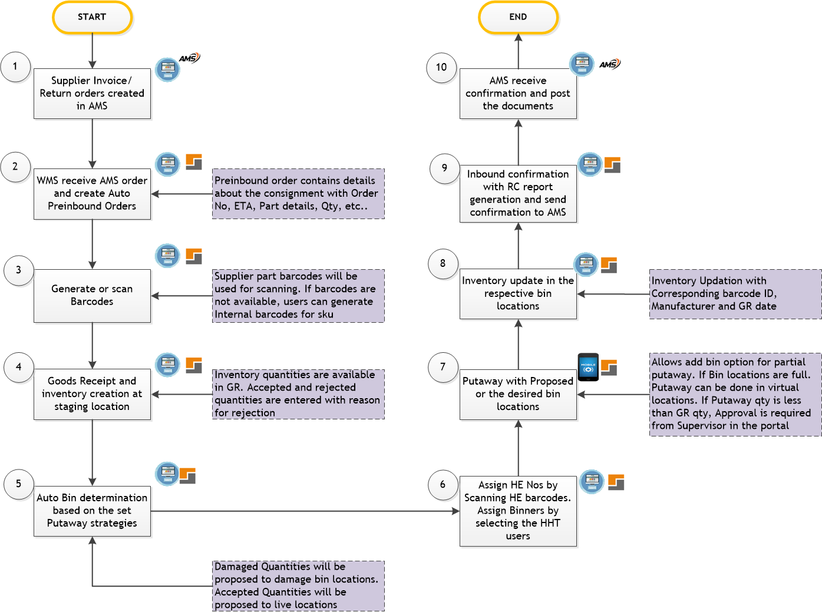

### **Process Steps:**

1. Inbound Process for AlMailem Amghara Warehouse has three process

* Inbound parts against supplier invoices
* Inbound Parts against Return orders from customers/branches
* Inbound parts against stock transfer order from branches

1. Supplier invoices/ return orders/STO will be created in AMS by procurement team/ corresponding branches/ Amghara team.

Classic WMS will receive the orders through integration in real time. Field details of each order type for integration need to be discussed and firmed up with AMS team. On successful receipt of orders from AMS, WMS will auto create Preinbound order numbers and each Preinbound order contains all the fields posted by AMS. All 3 types of Inbound will be differentiated by Order type IDs in Classic WMS.

1. Note: AMS can update the existing supplier invoice with the new part, alternate part and qty and send to Classic WMS through update Supplier invoice API and Classic WMS will update the corresponding records in the system. Classic WMS will not receive the changes for the confirmed status Part nos from the AMS through integration for the existing open Supplier invoice. In such scenario, AMS need to create new supplier invoice and send to Classic WMS.
2. After unloading the goods and moved into receiving area, below activities will be carried out in Classic WMS

* Container receipts can be recorded in Classic WMS according to business requirements.
* Supplier Barcodes of each part will be scanned for receiving the items. AlMailem requires HHT for receiving the part nos by scanning the barcode. If the scanned barcode is not available in Classic WMS, system will throw error in HHT and in such cases, User need to process those parts in portal. Barcode generation option will not be available in HHT
* If the scanned barcode is not available in the item master, user can generate a new barcode label by selecting the part and scanning the barcode ID.
* After Scanning the barcode, System will display the existing inventory details (Barcode, Bin location, qty, Manufacturer, Brand) in Pop up screen and Users can proceed with scanned barcode or generate a new barcode according to the business requirements.
* New barcodes need be generated for the below scenarios
* Same Part No with different Manufacturer
* Same Barcode from different Manufacturer
* Parts which are not having barcodes (Genuine and Aftermarket)
* Supplier barcodes with short names which are duplicated
* Same Part No/barcode, Same Manufacturer with different Company code (ASP/JSP)
* Genuine parts having suffix (Barcode generation is Optional)
* Aftermarket part carrying Same barcode of genuine part
* There are scenarios where Same Part no may come with a new barcode where existing inventory may have different barcode. In such cases, Classic WMS will allow to receive same part no with different barcodes (Genuine and Aftermarket) and maintain inventory of Same part no with different barcodes.
* **Note:**

**AlMailem need to provide supplier barcodes for each item during data migration which need to be matched with corresponding Physical barcodes.**

1. Goods Receipt will be done by Receiving team and the details required for GR are as below

* Part No (value from AMS system)
* Description (value from AMS system)
* Invoice No (value from AMS system)
* Invoice qty (value from AMS system)
* Inventory qty (stock qty from WMS)
* Barcode (Scan/ Generate) - Mandatory
* Accepted qty (Entry field) - Mandatory
* Rejected qty (Entry Field) - Mandatory
* Reason for rejection (Entry Field) - Optional
* CBM (L*B*H) - (Entry Field) - Optional
* Supplier code (value from AMS system)
* Manufacturer (value from AMS system)
* Brand (value from AMS system)

After entering the required details, confirm the goods receipt which will increase the stock at receiving staging location.

1. Once GR is confirmed, Classic WMS will determine Bin locations for each part no through below putaway strategies
2. Add to existing stock: If the stock of the receiving part is already available, system will propose the bin location where the stock already exists (Priority -1)
3. New Bin Location: If the stock is not available or a new part is received, an Empty bin location will be proposed by the system.
4. Virtual location: If the space is not available in any of the bin location in the warehouse, system will propose a virtual bin location to store the item.

Note: Live Bin locations will be proposed for Accepted qty and damage bin locations will be proposed for damage qty. (Note: Damage location details yet to be shared)

1. During GR confirmation, each pallet can be assigned to a Handling Equipment (HE) barcode by scanning the barcode and assigned to a binner by selecting the User.
2. Upon binner assignment, respective user will receive the HE barcodes information along with GR items in HHT under Putaway menu.

Binner will also receive details about the GR qty for each part no in the HHT device

Binner will scan the corresponding HE barcode in the pallet and pick the items for binning. Binning will be done at the proposed bin locations by scanning the location barcode and Part no barcodes.

1. After binning confirmation, stock will get added to the respective bin locations and Binning confirmation will be updated in the system.

If Binning qty is less than the GR qty, User will be allowed to confirm binning only after the approval which will be done by the Supervisor in the Portal

1. Upon Binning all the items successfully, Receipt confirmation will be done in the Classic WMS portal by the supervisor after validating all the receipts through RC report.
2. Once receipt is confirmed in the Classic WMS systems, confirmation details will be sent to AMS through integration for the corresponding confirmation and AMS will send success response to Classic WMS after the confirmation at its end.

## **Make and Change – Amghara**

## 

### **Process Flow**

### **Process Steps**

1. Make and Change in Amghara Warehouse covers the below process

* Stock type to Stock type transfer
* Bin to Bin transfer

Stock type to Stock type: Allows to transfer stock type from On-hand to Hold or from Hold to On-Hand for a Sku in a Warehouse without order reference.

Bin to Bin transfer: Allows to transfer stock of multiple Skus from one Bin location to another Bin location in a warehouse

1. Transfer Method used for Amghara Warehouse will be One step transfer.
2. For all transfers Source and target details need to be filled in the system

* For Stock type to Stock type – Source Sku / Stock type and Target Sku/Stock type/Bin locations need to be filled along with transfer qty
* For Bin to Bin transfer – Source Sku /Bin location and Target Sku/Bin location need to be filled along with transfer qty

1. On Confirming the transfers, corresponding stock will be updated in the source and target locations according to the selected transfer process.

## **Outbound - Amghara**

### **Process Flow**

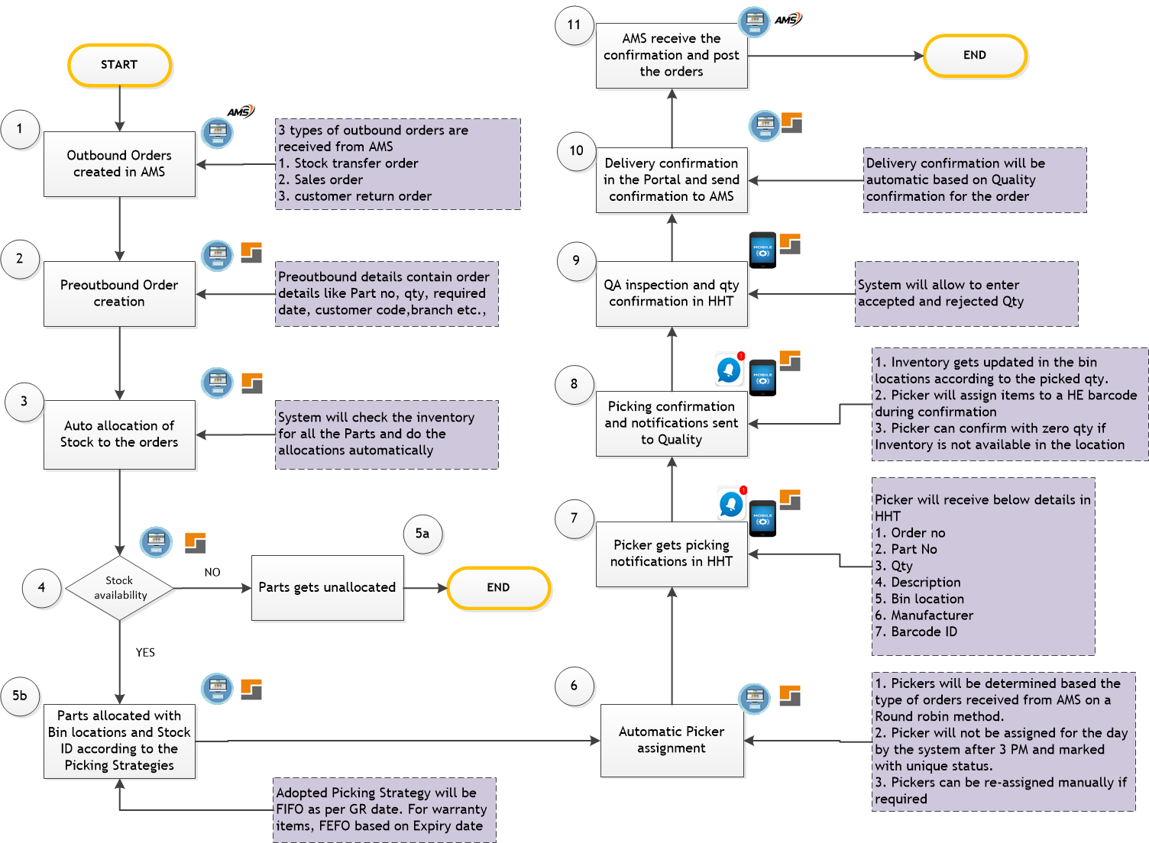

### **Process Steps**

1. Outbound Process in Amghara Warehouse contains 3 scenarios

* Stock transfer from Amghara to Branches based on Push or Pull orders from AMS
* Delivery against Sale Orders from AMS
* Returning the Parts based on Return order from AMS

For all the above scenarios, Corresponding order will be initiated from AMS and send to Classic WMS through integration. Classic WMS will receive these orders and map to corresponding order type IDs to identify the order types.

1. Once the Orders received successfully into Classic WMS system, unique Preoutbound order gets generated automatically which contains all the details of the orders received from AMS. The details required for Classic WMS are below

* Warehouse No
* Order No
* Required date
* Line No
* Part No
* Description
* Customer details for Sale order
* Branch/Warehouse for Stock transfer order and returns
* Qty
* Manufacturer
* Brand

1. System will do the automatic stock availability check in the entire warehouse to reserve the stock for the received orders. Stock reservation will follow FIFO of the received orders date. Stock considered for availability check will exclude the staging bin locations and the stock on hold.
2. Stock availability check may have 3 possible results –

* Stock available in full,
* Partially available
* Not available.

1. If the stock is not available to fulfill the order quantities, corresponding Skus will be unallocated and the respective status will be changed against the Parts in the order.

If the stock is available in partial, partial quantities are allocated for the order and the status of the parts will be partially allocated.

If the stock is available to fulfill the order quantities, corresponding quantities will be allocated and the status will be assigned as allocated. During allocation respective stock will be moved from on hand to Allocated stock type automatically.

Stock moved to allocated will not be considered for stock availability check for the future orders. Stock allocation will follow the picking strategy defined in the system. For Amghara warehouse, adopted picking strategy will be FIFO based on GR date. Stocks received from oldest to New dates will be sorted and proposed for picking. For Warranty parts, picking strategy will follow FEFO based on Expiry dates.

If a Bin location contains two different stock of different GR dates, both the stock will be proposed for picking. In this FIFO strategy will be skipped as this type of allocation will reduce the picking from multiple bin locations.

1. Once the stock is allocated in full or partial, picker assignments will be done automatically by the System. Picker assignment will follow the below process

* Each Picker will be mapped to an order type (STO/Sale order/Return order) in the User master
* During Picker assignment, system will pick the corresponding pickers according to the order types and assign the picker based on whomever is available early for picking.
* There will be a Picker assignment cut-off time which is at 3:00 PM every day. Any orders received after 3 PM will not be assigned for picking by the system and these orders will be marked with status as “Waiting for Picker assignment” and these orders will be assigned for picking by the Supervisors manually.
* Classic WMS will also provide the option to re-assign the pickers if required before Picking confirmation
* Classic WMS will also allow the supervisors to change the Pickers mapping to the order types

1. Once picker is assigned successfully, picking transfer order gets generated automatically by the Classic WMS and send the order notifications to the pickers in HHT.

Picking orders will contain below details in HHT

* Order No
* Part no
* Description
* Pick Qty
* Bin location
* Barcode
* Manufacturer

1. Pickers will pick the respective Parts by scanning the proposed bin locations, scanning the barcodes and entering the picked quantities.

Classic WMS will also allow the pickers to pick the Skus from multiple bin locations if required by selecting the Add bin option.

Once the Picking is confirmed by the picker, inventory of the picked bin locations will get reduced automatically and the picked qty will be moved to Quality staging location.

During Picking confirmation, a handling equipment number’s barcode is scanned and assigned for to each picked Part No

Classic WMS will allow Pickers to deny the picking orders by confirming zero quantities if the stock is not available.

1. Classic WMS will send notifications to Quality in HHT once the picking is confirmed. QA inspectors will scan the Handling equipment barcode in HHT (scanning should be optional) and inspect the Parts. Once the inspection is completed successfully, accepted and rejected quantities are entered and Quality process is confirmed in HHT. Quality confirmation will move the inventory from Quality staging location to delivery staging location.
2. Once QA check is done successfully for all the parts in the order, Delivery confirmation is done in the portal by the users after validating all the parts are picked as per order quantities.
3. Once Delivery is confirmed, inventory will get reduced from Delivery staging location and eventually from the warehouse. Confirmation details are sent to AMS and AMS will send success response to Classic WMS once the process is completed at its end.

There are 4 possible scenarios after sending shipping confirmation from WMS and before Sales invoice generation.

1. Adding Sales order qty for the items in the pick list:

Items with added qty (Delta) will be received in WMS through API from AMS and a Preoutbound No generated automatically in WMS which will refer to the same sales order no of AMS and after Picking and QA, shipping confirmation will be done and pushed to AMS.

1. Reducing Sales order qty for the items in the pick list:

If the item quantities are reduced in AMS, those items with reduced qty will be received in WMS as Return order from AMS via API and a Preinbound order no will be generated automatically which will be mapped to same Sales order No and the reduced quantities will be transferred from the delivery locations to the live location by Goods receipt and Binning by scanning the barcodes. Corresponding items in the Outbound order will be updated with status as updated.

1. Deletion of 1 or multiple items in the pick list.

If an item/multiple items deleted or cancelled in AMS, those items will be received as return order and a Preinbound order no will be generated automatically which will refer to same Sales order No and the reduced quantities will be transferred from the delivery locations to the live location by Goods receipt and Binning by scanning the barcodes. Corresponding item in the Outbound order will be updated with status as cancelled

1. Deletion of entire pick list

If a pick list is deleted or cancelled in AMS, those items will be received as return order and a Preinbound order no will be generated automatically which will refer to same Sales order No and the reduced quantities will be transferred from the delivery locations to the live location by Goods receipt and Binning by scanning the barcodes. Corresponding Picklist in the Outbound will be updated with status as cancelled

Note: If the items are delivered to the customers at the counters and Sales Men after updating the status of sales invoice as delivered, corresponding status has to be sent to WMS for updating the status of the Picklist as delivered

## **Stock Count (Perpetual and Periodic)**

### **Process Flow**

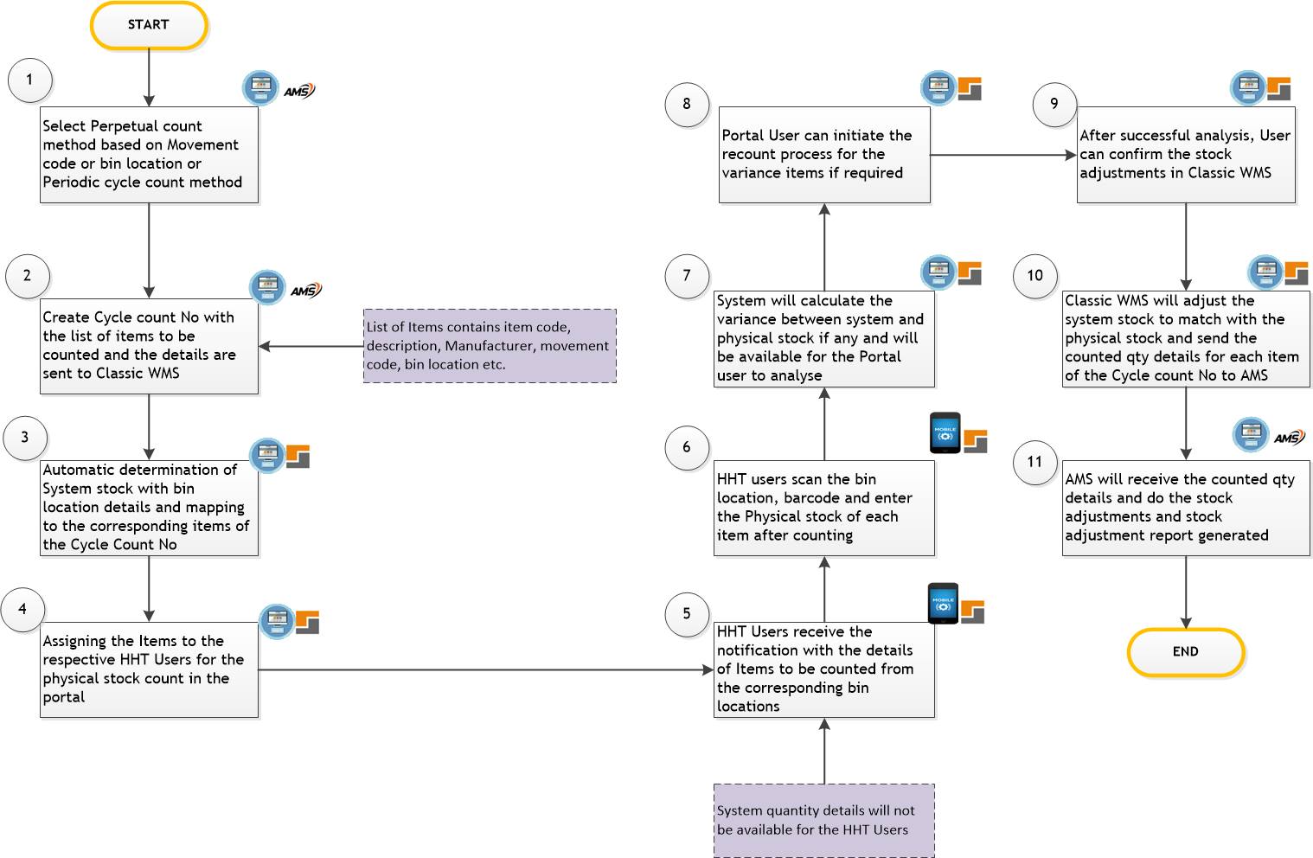

### **Process Steps**

1. Stock count process for Amghara warehouse will be Perpetual stock count method based on Movement code or Bin location and Periodic stock count will include all items of the Warehouse. Users will select the appropriate Perpetual stock count method in AMS system and execute
2. AMS will create a cycle count No for each run and will list the items to be counted for the generated Cycle count No. List of items will contain the details of Item code, Description, Bin location, Movement code and Manufacturer. All the details of Cycle count record then will be pushed to Classic WMS.
3. Classic WMS will receive the Cycle Count record details and fetch the Bin location details and system qty for each item and map to the corresponding items of the Cycle count Number
4. Authorized portal user will assign the items to the respective HHT users to initiate the Physical stock count.
5. HHT users receive the notifications about the assigned items with the details of Manufacturer, bin locations. System stock details are not available for HHT users
6. HHT users will scan the bin locations and barcodes for the assigned items and enter the physical quantity
7. System will calculate the variance between system qty and Physical qty and calculate the variance. System will also consider the Picked and received quantities in the bin locations that happened before Physical stock count and include that for the variance calculation.
8. Authorized Portal user can initiate the recount process for the variance items if required
9. After successful analysis, authorized user can confirm the stock adjustments in Classic WMS.
10. Classic Wms Will adjust the system stock to match with the physical stock and send the counted qty details of each item to AMS through integration API. Variance report can be generated in Classic WMS. Classic WMS can also send actual stock counted bin location details to AMS if required.
11. AMS will receive the cycle count record details from Classic WMS and stock adjustment entries will be posted in AMS and adjustment report can be generated in AMS
12. Classic WMS will also provide the option to skip the items from the stock count if required. AMS need to confirm the feasibility on receiving the skip items details.

## **Inbound – Auto Lab**

### **Process Flow**



### **Process Steps:**

1. Inbound Process for AlMailem Auto Lab Warehouse has three process

* Inbound parts against supplier invoices
* Inbound Parts against Return orders from customers/branches
* Inbound parts against stock transfer order from branches

1. Supplier invoices/ return orders/STO will be created in AMS by procurement team/ corresponding branches/ Auto Lab team.

Classic WMS will receive the orders through integration in real time. Field details of each order type for integration need to be discussed and firmed up with AMS team. On successful receipt of orders from AMS, WMS will auto create Preinbound order numbers and each Preinbound order contains all the fields posted by AMS. All 3 types of Inbound will be differentiated by Order type IDs in Classic WMS

Note: AMS can update the existing supplier invoice with the new part, alternate part and qty and send to Classic WMS through update Supplier invoice API and Classic WMS will update the corresponding records in the system. Classic WMS will not receive the changes for the confirmed status Part nos from the AMS through integration for the existing open Supplier invoice. In such scenario, AMS need to create new supplier invoice and send to Classic WMS.

1. After unloading the goods and moved into receiving area, below activities will be carried out in Classic WMS

* Container receipts can be recorded in Classic WMS according to business requirements.
* Supplier Barcodes of each part will be scanned for receiving the items. AlMailem requires HHT for receiving the part nos by scanning the barcode. If the scanned barcode is not available in Classic WMS, system will throw error in HHT and in such cases, User need to process those parts in portal by selecting the item code or description. Barcode generation option will not be available in HHT
* After Scanning the barcode, System will display the existing inventory details (Barcode, Bin location, qty, Manufacturer, Brand) in Pop up screen and Users can proceed with scanned barcode or generate a new barcode according to the business requirements.
* New barcodes need be generated for the below scenarios
* Same Part No with different Manufacturer
* Same Barcode from different Manufacturer
* Parts which are not having barcodes (Genuine and Aftermarket)
* Supplier barcodes with short names which are duplicated
* Same Part No/barcode, Same Manufacturer with different Company code (ASP/JSP)
* Genuine parts having suffix (Barcode generation is Optional)
* Aftermarket part carrying Same barcode of genuine part
* There are scenarios where Same Part no may come with a new barcode where existing inventory may have different barcode. In such cases, Classic WMS will allow to receive same part no with different barcodes (Genuine and Aftermarket) and maintain inventory of Same part no with different barcodes.
* **Note: AlMailem need to provide supplier barcodes for each item during data migration which need to be matched with corresponding Physical barcodes.**

1. Goods Receipt will be done by Receiving team and the details required for GR are as below

* Part No (value from AMS system)
* Description (value from AMS system)
* Invoice No (value from AMS system)
* Invoice qty (value from AMS system)
* Inventory qty (stock qty from WMS)
* Barcode (Scan/ Generate) - Mandatory
* Accepted qty (Entry field) - Mandatory
* Rejected qty (Entry Field) - Mandatory
* Reason for rejection (Entry Field) - Optional
* CBM (L*B*H) - (Automatic from Item Master) - Mandatory
* Supplier code (value from AMS system)
* Manufacturer (value from AMS system)
* Brand (value from AMS system)

After entering the required details, confirm the goods receipt which will increase the stock at receiving staging location.

1. Once GR is confirmed, Classic WMS will determine Bin locations for each part no through below putaway strategies
2. Add to existing stock: If the stock of the receiving part is already available, System will get those bin locations and estimate the remaining capacity available in each bin location. system will propose the bin location where the Item’s total capacity (CBM) matches with Bin’s Capacity in full or Partial. Remaining item will be proposed to the next empty bin location. (Priority -1)
3. New Bin Location: If the stock is not available or a new part is received, an Empty bin location will be proposed by the system. (Priority-2)
4. Virtual location: If the space is not available in any of the bin location in the warehouse, system will propose a virtual bin location to store the item. (Prioirty-3)

Note: Live Bin locations will be proposed for Accepted qty and damage bin locations will be proposed for damage qty (Damage bin location details need to be shared)

1. During GR confirmation, each pallet can be assigned to a Handling Equipment (HE) barcode by scanning the barcode and assigned to a binner by selecting the User.
2. Upon binner assignment, respective user will receive the HE barcodes information along with GR items in HHT under Putaway menu.

Binner will also receive details about the GR qty for each part no in the HHT device

Binner will scan the corresponding HE barcode in the pallet and pick the items for binning. Binning will be done at the proposed bin locations by scanning the location barcode and Part no barcodes.

1. After binning confirmation, stock will get added to the respective bin locations and Binning confirmation will be updated in the system. Also, Bin location capacity will get updated in the system.

If Binning qty is less than the GR qty, User will be allowed to confirm binning only after the approval which will be done by the Supervisor in the Portal

1. Upon Binning all the items successfully, Receipt confirmation will be done in the Classic WMS portal by the supervisor after validating all the receipts through RC report.
2. Once receipt is confirmed in the Classic WMS systems, confirmation details will be sent to AMS through integration for the corresponding confirmation and AMS will send success response to Classic WMS after the confirmation at its end.

## **Make and Change – Auto Lab**

### **Process Flow**

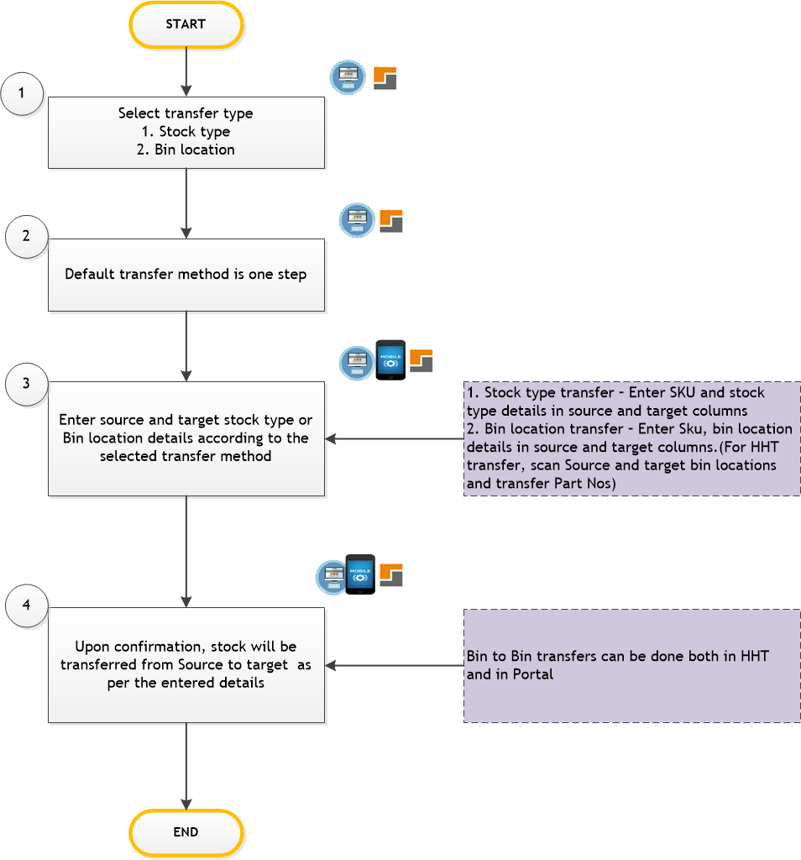

### **Process Steps**

1. Make and Change in Auto Lab covers the below process

* Stock type to Stock type transfer
* Bin to Bin transfer

Stock type to Stock type: Allows to transfer stock type from On-hand to Hold or from Hold to On-Hand for a Sku in a Warehouse without order reference

Bin to Bin transfer: Allows to transfer stock of multiple Skus from one Bin location to another Bin location in a warehouse

1. Transfer Method used for Auto Lab Warehouse will be One step transfer.
2. For all transfers Source and target details need to be filled in the system

* For Stock type to Stock type – Source Sku / Stock type and Target Sku/Stock type/Bin locations need to be filled along with transfer qty
* For Bin to Bin transfer – Source Sku /Bin location and Target Sku/Bin location need to be filled along with transfer qty

1. On Confirming the transfers, corresponding stock will be updated in the source and target locations according to the selected transfer process.

## **Outbound – Auto Lab**

### **Process Flow**

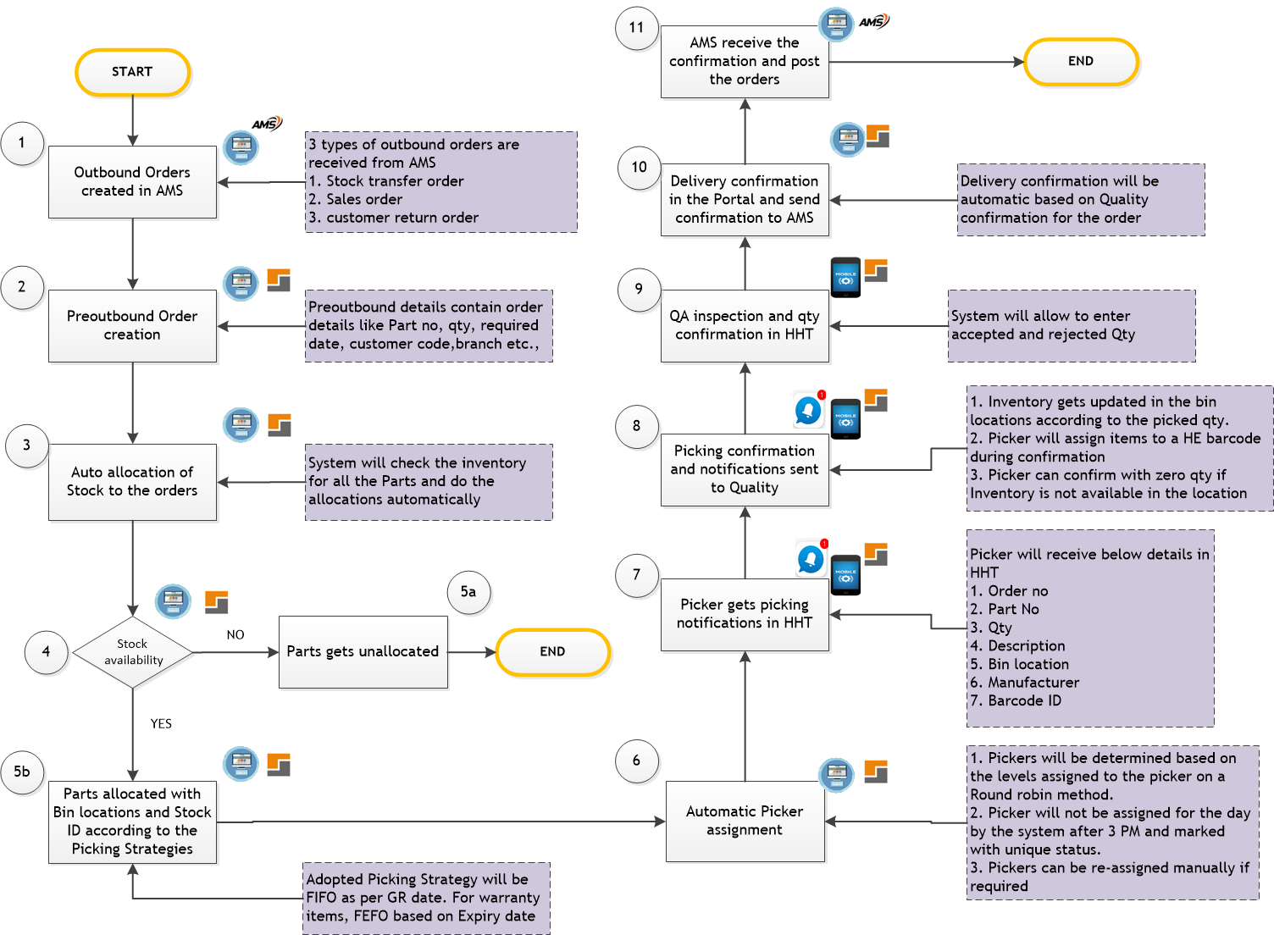

### **Process Steps**

1. Outbound Process in Auto Lab Warehouse has 3 Scenarios

* Stock transfer from Auto Lab to Branches based on Push or Pull orders from AMS
* Delivery against Sale Orders from AMS
* Returning the Parts based on Return order from AMS

For all the above scenarios, Corresponding order will be initiated from AMS and send to Classic WMS through integration. Classic WMS will receive these orders and map to corresponding order type IDs to identify the order types.

1. Once the Orders received successfully into Classic WMS system, unique Preoutbound order gets generated automatically which contains all the details of the orders received from AMS. The details required for Classic WMS are below

* Warehouse No
* Order No
* Required date
* Line No
* Part No
* Description
* Customer details for Sale order
* Branch/Warehouse for Stock transfer order and returns
* Qty
* Manufacturer
* Brand

1. System will do the automatic stock availability check in the entire warehouse to reserve the stock for the received orders. Stock reservation will follow FIFO of the received orders date. Stock considered for availability check will exclude the staging bin locations and the stock on hold.
2. Stock availability check may have 3 possible results –

* Stock available in full,
* Partially available
* Not available.

1. If the stock is not available to fulfill the order quantities, corresponding Skus will be unallocated and the respective status will be changed against the Parts in the order.

If the stock is available in partial, partial quantities are allocated for the order and the status of the parts will be partially allocated.

If the stock is available to fulfill the order quantities, corresponding quantities will be allocated and the status will be assigned as allocated. During allocation respective stock will be moved from on hand to Allocated stock type automatically.

Stock moved to allocated will not be considered for stock availability check for the future orders. Stock allocation will follow the picking strategy defined in the system. For Auto Lab warehouse, adopted picking strategy will be FIFO based on GR date. Stocks received from oldest to New dates will be sorted and proposed for picking. For Warranty parts, picking strategy will follow FEFO based on Expiry dates.

If a Bin location contains two different stock of different GR dates, both the stock will be proposed for picking. In this FIFO strategy will be skipped as this type of allocation will reduce the picking from multiple bin locations.

1. Once the stock is allocated in full or partial, picker assignments will be done automatically by the System. Picker assignment will follow the below process

* Each Picker will be mapped to a level in the User master
* Picking Process follows level-based picking. Order Parts are segregated according to the levels and assigned to the respective level Pickers.
* During Picker assignment, system will pick the corresponding pickers according to the level and assign the picker based on whomever is available early for picking.
* There will be a Picker assignment cut-off time which is at 3:00 PM every day. Any orders received after 3 PM will not be assigned for picking by the system and these orders will be marked with status as “Waiting for Picker assignment” and these orders will be assigned for picking by the Supervisors manually.
* Classic WMS will also provide the option to re-assign the pickers if required before Picking confirmation
* Classic WMS will also allow the supervisors to change the Pickers mapping to the levels in the user master

1. Once picker is assigned successfully, picking transfer order gets generated automatically by the Classic WMS and send the order notifications to the pickers in HHT.

Picking orders will contain below details in HHT

* Order No
* Part no
* Description
* Pick Qty
* Bin location
* Barcode
* Manufacturer

1. Pickers will pick the respective Parts by scanning the proposed bin locations, scanning the barcodes and entering the picked quantities.

Classic WMS will also allow the pickers to pick the Skus from multiple bin locations if required by selecting the Add bin option.

Once the Picking is confirmed by the picker, inventory of the picked bin locations will get reduced automatically and the picked qty will be moved to Quality staging location. Also, the Capacity (CBM) of the bin locations reduced automatically. During Picking confirmation, a handling equipment number’s barcode is scanned and assigned for to each picked Part No. Classic WMS will allow Pickers to deny the picking orders by confirming zero quantities if the stock is not available.

1. Classic WMS will send notifications to Quality in HHT once the picking is confirmed. QA inspectors will scan the Handling equipment barcode in HHT (scanning should be optional) and inspect the Parts. Once the inspection is completed successfully, accepted and rejected quantities are entered and Quality process is confirmed in HHT. Quality confirmation will move the inventory from Quality staging location to delivery staging location. QA inspectors will group the parts received from Multiple levels through HE according to the AMS order
2. Once QA check is done successfully for all the parts in the order, Delivery confirmation is done in the portal by the users after validating all the parts are picked as per order quantities.
3. Once Delivery is confirmed, inventory will get reduced from Delivery staging location and eventually from the warehouse. Confirmation details are sent to AMS and AMS will send success response to Classic WMS once the process is completed at its end.

There are 4 possible scenarios after sending shipping confirmation from WMS and before Sales invoice generation.

1. Adding Sales order qty for the items in the pick list:

Items with added qty (Delta) will be received in WMS through API from AMS and a Preoutbound No generated automatically in WMS which will refer to the same sales order no of AMS and after Picking and QA, shipping confirmation will be done and pushed to AMS.

1. Reducing Sales order qty for the items in the pick list:

If the item quantities are reduced in AMS, those items with reduced qty will be received in WMS as Return order from AMS via API and a Preinbound order no will be generated automatically which will be mapped to same Sales order No and the reduced quantities will be transferred from the delivery locations to the live location by Goods receipt and Binning by scanning the barcodes. Corresponding items in the Outbound order will be updated with status as updated.

1. Deletion of 1 or multiple items in the pick list.

If an item/multiple items deleted or cancelled in AMS, those items will be received as return order and a Preinbound order no will be generated automatically which will refer to same Sales order No and the reduced quantities will be transferred from the delivery locations to the live location by Goods receipt and Binning by scanning the barcodes. Corresponding item in the Outbound order will be updated with status as cancelled

1. Deletion of entire pick list

If a pick list is deleted or cancelled in AMS, those items will be received as return order and a Preinbound order no will be generated automatically which will refer to same Sales order No and the reduced quantities will be transferred from the delivery locations to the live location by Goods receipt and Binning by scanning the barcodes. Corresponding Picklist in the Outbound will be updated with status as cancelled

Note: If the items are delivered to the customers at the counters and Sales Men after updating the status of sales invoice as delivered, corresponding status has to be sent to WMS from AMS for updating the status of the Picklist as delivered

## **Stock Count**

### **Process Flow**



### **Process Steps**

1. Stock count process for Amghara warehouse will be Perpetual stock count method based on Movement code or Bin location and all items will be considered for Periodic stock count. Users will select the appropriate Perpetual stock count method in AMS system and execute
2. AMS will create a cycle count No for each run and will list the items to be counted for the generated Cycle count No. List of items will contain the details of Item code, Description, Bin location, Movement code and Manufacturer. All the details of Cycle count record then will be pushed to Classic WMS.
3. Classic WMS will receive the Cycle Count record details and fetch the Bin location details and system qty for each item and map to the corresponding items of the Cycle count Number
4. Authorized portal user will assign the items to the respective HHT users to initiate the Physical stock count.
5. HHT users receive the notifications about the assigned items with the details of Manufacturer, bin locations. System stock details are not available for HHT users
6. HHT users will scan the bin locations and barcodes for the assigned items and enter the physical quantity
7. System will calculate the variance between system qty and Physical qty and calculate the variance. System will also consider the Picked and received quantities in the bin locations that happened before Physical stock count and include that for the variance calculation.
8. Authorized Portal user can initiate the recount process for the variance items if required
9. After successful analysis, authorized user can confirm the stock adjustments in Classic WMS.
10. Classic Wms Will adjust the system stock to match with the physical stock and send the counted qty details of each item to AMS through integration API. Variance report can be generated in Classic WMS. Classic WMS can also send actual stock counted bin location details to AMS if required.
11. AMS will receive the cycle count record details from Classic WMS and stock adjustment entries will be posted in AMS and adjustment report can be generated in AMS
12. Classic WMS will also provide the option to skip the items from the stock count if required. AMS need to confirm the feasibility on receiving the skip items details.

# **Stock Transfers between Warehouses**

## **Process Flow**

## **Process Steps**

1. For stock transfers from one branch to another branch where WMS is implemented, Stock transfer will follow two step process in Classic WMS and AMS. Transfer orders will be created at Source branch in AMS and marked with corresponding status in AMS and Transfer order will be sent to Classic WMS
2. Classic WMS will receive the transfer order at Source branch with Order type as WH2WH – OUT and create a Preoutbound order automatically
3. All outbound process of Warehouse which includes order allocation, Picker assignment, Picking, Quality check and Outbound confirmation will be done in Classic WMS at the source branch
4. After Outbound confirmation, Classic WMS will send confirmation details to AMS from Source branch
5. Source branch will receive the confirmation in AMS and update the relevant details in the corresponding transfer order
6. AMS will then push the transfer order to Classic WMS from the receiving Branch
7. Classic WMS will be receiving the Transfer order at the receiving branch with order type as WH2WH – IN and create a Preinbound Order automatically
8. All inbound process of Warehouse which includes Goods Receipt, Binner assignment, Binning, Inbound confirmation will be done in Classic WMS at the receiving branch
9. Classic WMS will then send Receipt confirmation details to AMS for the respective transfer order
10. AMS will receive the confirmation details at the receiving branch from Classic WMS and post the order

# **Delivery Module**

## **Process Flow**

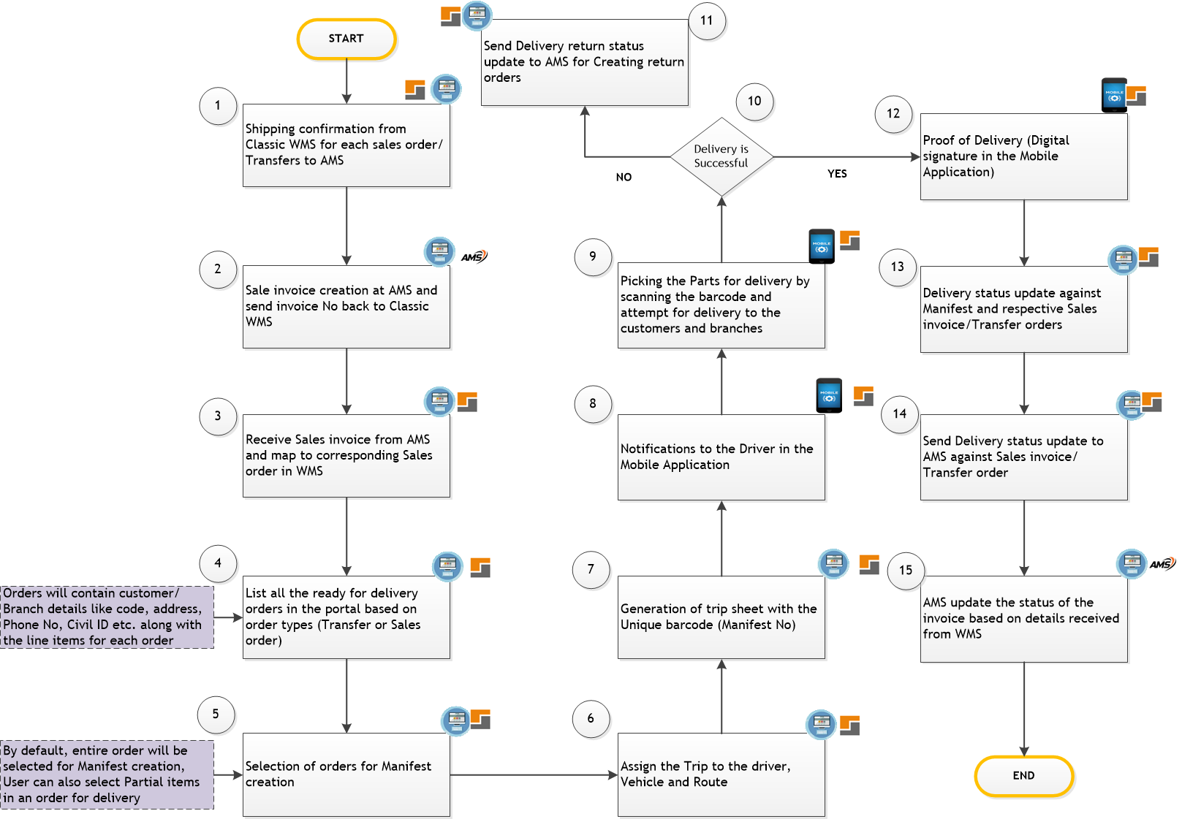

## **Process Steps**

Delivery Process at Amhara and Auto Lab will follow the below process

1. After Confirming the Sale orders and transfer orders shipping, corresponding details will be sent to AMS for Posting the Pick list
2. AMS will generate Sales Invoice and send the Invoice Number to Classic WMS through integration for each Sales Order.
3. Classic WMS will receive Sales Invoice from AMS and update against the respective Sales order
4. Ready for delivery orders will then be listed in the portal under Delivery module. Orders will be differentiated based on Order types (Transfers or Sales). Orders will contain the information about Customer/Branch ID, Address, Phone No etc. along with Item details in each order
5. Users will select the orders for creating a manifest. There will be 2 trips for the day at Amghara and Auto Lab to Branches and customer deliveries. Users are allowed to select the line items partially with the order
6. Users will select the Driver for the Manifest and system will propose the vehicle and route ID from the Master. User are allowed to edit the vehicle and route ID if required. (no of Vehicles/Drivers at Amghara -12 and no of Vehicles/Drivers at Auto Lab will be 7 to 8)
7. Once the driver/vehicle/Route are assigned successfully, trip sheet will be generated in the portal with Unique barcode ID. Trip Sheet can be printed and will be kept along with physical items. Manifest will be updated with assigned Driver, vehicle and route details
8. In-app trip Notifications will be sent to the assigned drivers in their Mobile devices.
9. Respective Drivers will pick the items by scanning the Manifest No barcode in the mobile devices and scanning the corresponding item barcodes. Status of Picking will be updated against each sales order/ transfer orders along with Date and time of loading.
10. Driver will carry the items and attempt to deliver. If Delivery is successful
11. Proof of Delivery will be received from customers through digital signature in the mobile application and that confirms the delivery
12. If Items are returned due to various reason, corresponding status of the orders will be updated as returned in Classic WMS and then sent back to AMS for initiating the returns process.
13. Once POD is received from Customers, Delivery status will be updated as Delivered in Classic WMS against each order.
14. Respective Delivery status will be sent to AMS for updating the Sales invoice /Transfer order status. For Partially delivered items, Status will not be sent to AMS till the completion of delivery for all items in the order.

# **Reports and Dashboard**

Below reports and dashboard are applicable for AlMailem (Amghara & Auto Lab) Warehouses

## **Reports**

1. Stock report by Part No
2. Stock report by Bin location
3. Stock Movement report
4. Outbound Order status report
5. Shipment delivery summary report
6. Shipment delivery dispatch report
7. Container status report
8. Picking report
9. Total stock movement report
10. Transfer report
11. Binning report
12. Inbound Order summary report
13. Delivery module report

## **Dashboard**

1. Container receipts – for the day
2. No of Invoices confirmed – for the day
3. No of Items received – for the day
4. Container receipts – for the Month
5. No of Invoices confirmed – for the Month
6. No of Items received – for the Month
7. No of Sales orders confirmed- for the day
8. No of transfer orders confirmed – for the day
9. No of Items delivered through sales orders – for the day
10. No of Items delivered through delivery orders – for the day
11. No of Sales orders confirmed- for the Month
12. No of transfer orders confirmed – for the Month
13. No of Items delivered through sales orders – for the Month
14. No of Items delivered through delivery orders – for the Month
15. Stock Status (Opening and Closing balance for the day)

# **Forms**

Below forms are applicable for AlMailem (Amghara & Auto Lab) warehouses

1. Receipt Confirmation report - Inbound confirmation
2. Shipment report – Outbound Confirmation
3. Trip Sheets for Delivery

# **Open Points**

1. Need of Sales invoice hard copy for delivery and POD to be confirmed by AlMailem
2. Damage locations for Auto Lab need to be shared
3. Bin locations for Amghara need to be shared
4. Format for Delivery sheet need to be shared
5. Format of Item labels along with label size to be confirmed
6. For Counter sales, corresponding delivery status has to be sent back to WMS from AMS after delivery is completed.

# **Points Discussed**

1. Report field level changes to be finalized during UAT and requirements which comes after UAT will be considered for development after Go-Live
2. Barcode details of the existing stock at Amghara Warehouse will not be stored in Classic WMS during Go Live. Hence Parts identification by scanning the barcodes for the existing inventory is not possible. In those cases, barcode scan is optional in Picking.
3. Amghara Warehouse is not maintaining capacity for bin locations and Parts. Hence Capacity based storage is not applicable for Amghara warehouse
4. For receiving, during scan if the barcode didn’t select the respective item in supplier invoice, User need to search the item manually and enter the barcode information both in portal and HHT.
5. Alternate Part No/Super Seeded part no details will be maintained in AMS and that will come to Classic WMS through integration when the supplier invoice is created
6. A new item master will be created in Classic WMS for a branch whenever an item is extended to the corresponding branch.
7. Maintaining capacity for each bin location and item is mandatory at Auto Lab warehouse.
8. If there are any challenges in performing the transactions in HHT due to hardware issues, connectivity etc. corresponding transactions have to be done at the portal
9. During Inbound confirmation, if an Item part is confirmed and pushed to AMS for a supplier invoice, same item part can’t be pushed again to AMS from the supplier invoice.
10. Capacity based storage will be enabled only for Auto Lab warehouse in this phase. For Amghara Warehouse, business team need to identify the capacity for the bin locations and the Products and that will be implemented phase by phase at Amghara warehouse.
11. Multiple Login using Same User ID will be restricted in portal and HHT.
12. Sales order cancellation or update is not allowed in AMS before receiving the picking confirmation from WMS
13. Sales order cancellation or update is not allowed in AMS after generation of Sales invoice
14. Customer return before delivery or Customer return after delivery will be handled through return order
15. For transferring items from Amghara to Auto Lab and receiving the items at Auto Lab, an interim solution will be provided for receiving and binning. During receiving, scanning or generating the item barcode and Entering bin location is mandatory.